

FINAL REPORT

Web System And Technologies



**Muqadas shehzadi (01-135231-075)**

**HIBA SHAHID (01-135231-034)**

Contents

**Introduction:** 2

**Pain Points:** 2

For Customers: 2

For Service Providers: 3

**How Our Solution Solves These Problems?** 3

For Customers: 3

For Service Providers: 3

**Core User Functions:** 4

**Core Service Provider Functions:** 5

**Featured Services:** 6

**Development Model: Agile** 7

Reasons for Selecting Agile for KAARSAZ: 7

**Sprint Breakdown:** 8

**Project Timeline**: 8

Gantt Chart (Using LaTeX Overleaf) 8

Key Milestones and Deadlines: 9

**System Design and Diagrams:** 9

Use Case Diagram (Using PlantUML) 9

Sequence Diagram 9

**Expected Outcomes:** 9

**Conclusion and Future Work:** 9

Summary of the Proposal 9

Future Scope of the Project 10

HOME SERVICE BOOKING SYSTEM



# **Introduction:**

KAARSAZ is an innovative digital platform designed to revolutionize how customers access and book home services. Our web-based system connects users with trusted service providers for plumbing, electrical work, cleaning, and other essential home services, offering a seamless booking experience with unique negotiable deals. By digitizing the entire home service process - from discovery to booking to payment - KAARSAZ eliminates the hassles of phone calls, uncertain pricing, and scheduling conflicts. Our platform empowers both customers seeking reliable services and providers looking to expand their client base through a structured, transparent marketplace.

# **Pain Points:**

## **For Customers:**

* **Unreliable Providers**: Having trouble locating dependable, high-caliber service providers
* **Price Uncertainty**: Inconsistent pricing might cause difficulties negotiating and perhaps overcharging**.**
* **Booking Inconvenience:** The inconvenient aspect of booking is having to call during business hours and wait for a callback.
* **Problems with scheduling:** No real-time information on provider availability
* **Payment Issues:** Cash-only transactions devoid of electronic payment methods

## **For Service Providers:**

* **Customer Acquisition:** It's challenging to continuously discover new customers
* **Scheduling Conflicts:** When appointments are managed manually, duplicate reservations occur.
* **Payment Delays:** Following up on payments after a job is finished.
* **Unpredictable workflow:** Trouble sustaining a consistent revenue stream.
* **High marketing costs:** Associated with promoting services through conventional channels.

# **How Our Solution Solves These Problems?**

## **For Customers:**

* **Trustworthy Suppliers:**

*Solution:* Verified profiles of service professionals with reviews and ratings

*Implementation:* Performance monitoring and background checks.

* **Clear and Open Pricing**

*Solution:* Clear pricing ranges with the ability to negotiate**.**

*Implementation:*The algorithm displays market rates along with a counteroffer option**.**

* **24/7 Reservations**

*Solution:*A real-time online reservation system

*Implementation:*A mobile and web interface featuring a calendar of real-time availability

* **Tracking in Real Time**

GPS-enabled cyclist tracking is the answer.

*Implementation:*Provider ETA is displayed on an integrated map interface.

* **Safe Transactions**

*Solution:*A variety of electronic payment methods

*Implementation***:** Combined cash-on-service option with payment gateway

## For Service Providers:

* **Client Engagement:**

*Solution:* Online marketplace exposure.

*Implementation:* Search enhancement and advertising placements.

* **Intelligent Planning**:

*Solution:* Automated scheduling calendar.

*Implementation:* Matches with provider's availability instantly.

* **Assured Payments:**

*Solution*: Escrow payment method

*Implementation:* Money retained until confirmation of job completion.

* **Consistent Process:**

*Solution:* Tools for forecasting demand.

*Implementation:* AI recommends ideal service zones/timings.

* **Free Marketing:**

*Solution:* Display of professional credentials.

*Implementation:* Platform manages online advertising

# **Core User Functions:**

* **Authentication of Users:**

System for customers and service providers to sign up and log in.

Management of profiles (personal information, preferred services)

* **Selection of Services:**

Examine the various home service categories, such as cleaning, electricity, and plumbing.

View supplier profiles and service details.

Services can be filtered by:

* Range of prices
* Accessibility
* Consumer evaluations
* Exclusive deals
* Offer Personalization
* **Management of Bookings:**

Set up services at your desired hours and dates.

Cancel or reschedule appointments.

See the history of reservations

* **Tracking in Real Time:**

Service providers' real-time GPS tracking ("Track the rider").

Updates on the estimated time of arrival (ETA).

Verification of service completion

* **Deals & Discounts:**

Use coupons to save up to 50%.

By rating, you can accrue loyalty points.

Go to the section with special offers.

Give friends access to discounts to earn referral bonuses.

* **Help & Support:**

The "Ask em!" customer service platform.

Questions about services.

Resolution of disputes.

Submission of feedback

# **Core Service Provider Functions:**

* **Management of Profiles:**

Make and modify profiles for professional services.

Upload your certifications and credentials.

Defined service regions and accessibility.

* **Offer Personalization:**

Establish a base price for the services.

Turn on or off the price-negotiation feature.

Make exclusive deals and discounts (up to 50%).

Accept or reject counteroffers from customers.

* **Management of Bookings:**

View and instantly confirm reservations.

Control the service calendar.

Cancel or reschedule appointments.

Configure automated availability patterns.

* **Execution of Services:**

Get client information and service needs.

Navigate to the "Track the Rider" system.

Mark tasks as "Completed," "En Route," and "In Progress."

Keep a record of service completion with remarks and images.

* **Interaction with Customers:**

Talk to clients before and after services.

Answer "Ask Em" questions.

Provide reports on service completion.

* **Earnings & Payment:**

View completed and pending payments.

Decide whether you want to pay in cash or digitally.

Keep track of your revenue and service history.

Take money out of your bank account.

* **Management of Reputation:**

View reviews and ratings from customers.

Answer reviews.

Monitor performance indicators.

Using ratings, raise the quality of services.

# **Featured Services:**

This area highlights a range of crucial services that users may obtain via the platform, guaranteeing ease of use and access to reliable suppliers.

* **Car Services – Toyota:**

This service provides options for auto repair and replacement parts. Top-notch auto service is guaranteed by Toyota-certified providers for everything from regular checkups to engine repairs and replacements of original spare parts.

* **Supplier:** Toyota
* **Phone number:** 01-135849309
* **Healthcare – Safari Hospital:**

In-home medical examinations, internet consultations, and emergency response support are just a few of the trustworthy and competent healthcare services offered by Safari Hospital. It easily links consumers with licensed medical providers.

* **Supplier:** Safari Hospital
* **Phone number:** 051-1358498
* **Grocery – Baqala Mart:**

Customers can use this service to place online grocery orders from Baqala Mart. Daily necessities including fruits, vegetables, snacks, and home goods are delivered quickly, and digital receipts are provided for transparency.

* **Supplier:** Baqala Mart
* **Phone number:** 061-1358493
* **Cleaning & Helper Services – CleanServicespro:**

Domestic assistance for housekeeping, organizing, and cleaning are the specialty of CleanServicespro. Their employees are verified, trained, and on-call to assist users in keeping their surroundings hygienic and safe.

* **Supplier:** CleanServicespro
* **Phone number:** 051-849309

**Technical specifications:**

* Frontend: JavaScript, HTML, CSS, and Bootstrap.
* Backend: C++ (REST API ).
* Database: MySQL
* Hosting: Web server-deployable after local testing using XAMPP/WAMP.

# **Development Model: Agile**

In order to provide a strong home service platform, we employed the Agile Development Model for KAARSAZ, emphasizing iterative development, ongoing user feedback, and adaptive planning.

**Plan of Implementation:**

* Two-week sprints that break down development into smaller, more manageable stages.
* All platform features are continuously tested.
* Priority-Based Development prioritizes the development of core functionalities.

## Reasons for Selecting Agile for KAARSAZ:

* **Quick Entry into the Market:**

permits the MVP (Minimum Viable Product) to be launched quickly, in two to three months.

While more features are developed, the early version can begin servicing consumers.

* **Integration of Real User Feedback:**

Customers and service providers can test features while they are being developed.

Instant integration of comments regarding:

* Usability of the negotiation system.
* Efficiency of the booking flow.
* Accuracy of rider tracking.
* **Ability to Adjust to Market Requirements:**

Adaptable to accommodate:

* New types of services.
* New forms of payment.
* Shifting consumer tastes.

Able to swiftly adapt to the needs of the local service provider.

* **Mitigation of Risk:**

Early detection of:

* Problems with pricing algorithms.
* Errors with GPS tracking.
* Issues with the payment gateway.

Last-minute system problems are avoided with continuous integration.

* **The Best Use of Resources:**

development in parallel of:

* Features that interact with customers.
* Tools for provider management.
* Control panels for administrators.

Effective utilization of the skills of the development team

* **An edge over competitors:**

quicker application of:

* Novel approaches to discounts.
* Tools for onboarding service providers.
* Features for retaining customers.

Fast reaction to movements made by competitors in the home services market.

# **Sprint Breakdown:**

|  |  |  |
| --- | --- | --- |
| Sprint | Tasks | Duration |
| Week 1-2 | Requirement Analysis and UI Design | 2 weeks |
| Week 3-4 | Frontend Development | 2 weeks |
| Week 5-6 | Backend and database | 2 weeks |
| Week 7 | Testing and debugging | 1 week |
| Week 8 | Deployment and Final Review | 1 week |

# **Project Timeline**:

## Gantt Chart (Using LaTeX Overleaf)

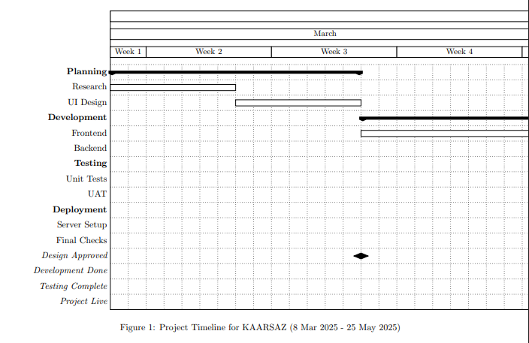

## Key Milestones and Deadlines:

|  |  |  |
| --- | --- | --- |
| Milestone | Description | Deadline |
| Project Kickoff | Repository setup, database design, and initial project structure | March 10, 2025 |
| Sprint 1 Completion | User authentication (login/signup) and basic profile management | March 20, 2025 |
| Sprint 2 Completion | Service listing, search functionality, and provider profiles | April 3, 2025 |
| Sprint 3 Completion | Booking system with calendar integration and real-time scheduling | April 17, 2025 |
| Beta Release | Minimum Viable Product (MVP) deployed for user testing | April 24, 2025 |
| Sprint 4 Completion | Payment gateway integration and negotiation features | May 8, 2025 |
| Final Testing | Comprehensive testing, bug fixes, and performance optimization | May 15, 2025 |
| Launch & Submission | Full deployment and project documentation completed | May 25, 2025 |

# **System Design and Diagrams:**

## Use Case Diagram (Using PlantUML)

## Sequence Diagram

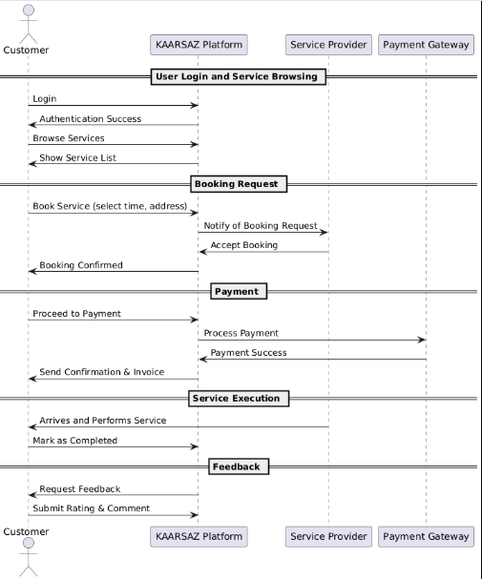

# **Expected Outcomes:**

* **For Clients**:

One-stop shop for scheduling vetted household services (plumbing, cleaning, etc.) at affordable prices.

Coupons for a 50% discount and real-time provider tracking ("Track the Rider").

Secure payments and open evaluations and ratings

* **For Service Suppliers**:

Expanded clientele as a result of increased online visibility.

Escrow-based payments and automated scheduling.

Lower marketing expenses thanks to integrated promotion tools.

* **Regarding Business:**

Service commission income (5–15% per booking).

Scalable model to reach new service categories and cities.

# **Conclusion and Future Work:**

## Summary of the Proposal

**Essential Features:**

* Authentication of users and providers.
* Finding services using filters (price, ratings).
* System for booking with real-time availability.
* Integration of payment gateways and GPS tracking

**Tech Stack:**

* **Frontend:** Bootstrap/React.js.
* **Backend:** Node.js(Express).
* **Database:** MySQL

## Future Scope of the Project

**Extension:** Include B2B services (e.g., event staffing, office maintenance) and incorporate AI-based pricing recommendations

**Improvements:**

* Plans for regular users to subscribe.
* Support for multiple languages for a wider audience

**Technology:**

* AR previews for service results (like assembling furniture, for example).
* Verification of contracts using block chain

**Partnerships:** Agreements to provide service assurances with insurance firms